The end of Daylight Savings

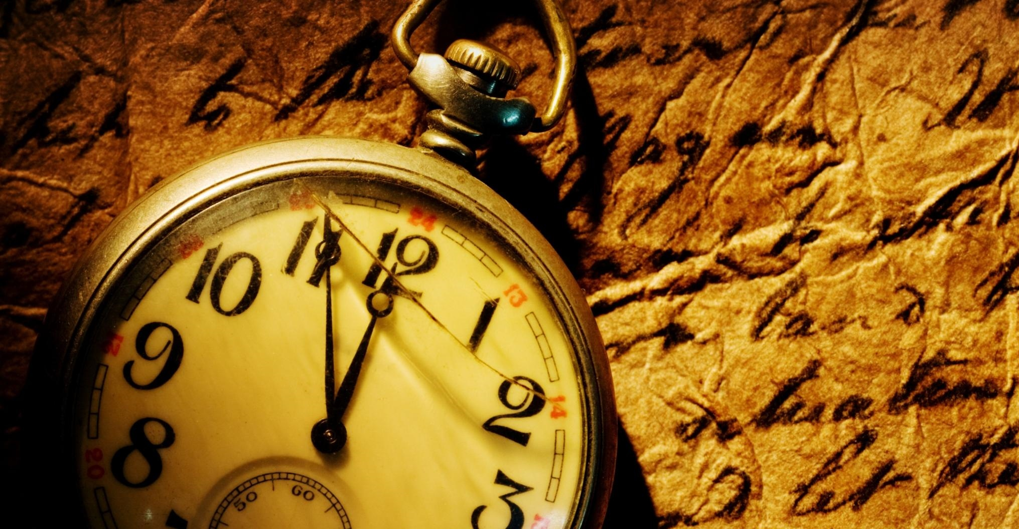

It’s the end of day light savings. Sigh! After we got our extra hour sleep last weekend, it now really feels like Autumn is here.
It’s that little bit harder to bounce out of bed and that little bit colder and darker when you finish work at the end of the day.

Transitioning through the seasons can be tough, if you don’t prepare and I am already starting to see patients presenting with cold and flu symptoms. The coldness in the air and less light influences our energy, sleep, mood and immune systems. You may have noticed that your sinus and glands are a little more clogged, your digestion and metabolism slowing down a notch and perhaps you’re craving more of those stodgy, warm meals.

Naturopaths top 5 tips:

- Sunshine breaks: Make time for 20-30minutes in direct sunlight daily over Autumn to stimulate your immune system, warm your soul and put a peaceful smile on your dile.
- Water: One of the main reasons we get more infections at this time of year is that the dry cold winds and heaters dry us out. This makes it difficult for our lymphatic system to clear out toxins and bugs. So keep topping up your water intake -drink it warm, hot, as herbal teas, with added cinnamon and honey, whatever it takes.
- Vitamin C: in autumn and winter, we naturally gravitate towards well cooked stews, casseroles, soups and other warm cooked meals. Less salads and fruit mean less vitamin C. Boost Vitamin C with a glass of fresh OJ, lemon water, and garnish meals with fresh parsley and coriander.
- Walking: Walking clears the mind and moves toxins and bugs through your system.

Article by Sophie Atkin, Naturopath@ North East Natural Health Centre

