Healthy oils
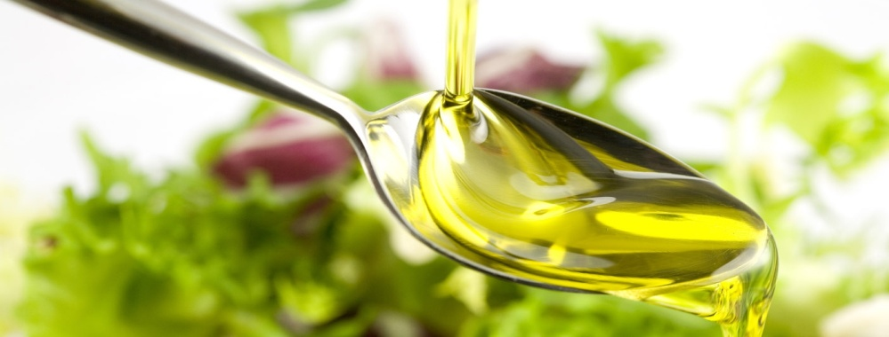

Oils & fats are an ongoing source of confusion. Herald as the cure and prevention of chronic inflammatory diseases, then demonized as a major contributor of these same conditions, it is not easy to get an answer. So are oils a friend or foe?

To truthfully answer this question we need to look at which oil is used at which time, the source of the oil, the way it is produced and stored. Some have high smoke temperatures and a long shelf life, others must strictly be served cold to gain maximum benefits and are best used within 12months of their production.

The naturopaths top 5 oils:

Oil | Heat or serve cold | Storing tips | Best use
Olive oil | Serve cold. Best raw. | Dark cupboard.  Use within 12months of production. | Drizzled over crispy bread, over steamed vegetables or pasta once cooked, in pesto, salad dressing.
Rice bran | Hot | Dark Cupboard | Mild flavour – best cooking oil.
Flax seed | Cold. Do not purchase if un-refrigerated. | Fridge | In smoothies, salad dressings, pesto.
Sesame oil | Hot or cold | Dark Cupboard | Best cooking oil for Asian foods, and salads.
Nuts & seeds | Cold. Do not heat | Fridge | Nuts are naturally high in oil and can be served alone, as nut butters (ABC spread, tahini) or extracted as crude oil (almond, macadamia, walnut)

Article by Naturopath Sophie Atkin @ North East Natural Health Centre

