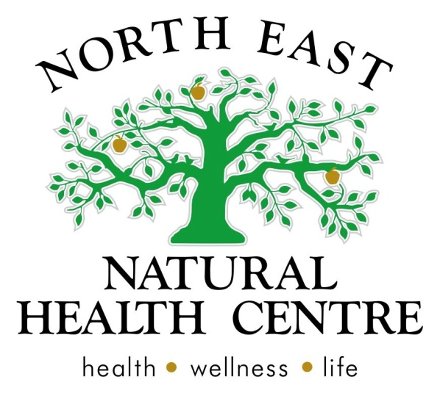

**Clinic News**

DearNorth East Natural Health Centre Newsletter  
  
The festive season is upon us and we would like to acknowledge and thank all of you for your wonderful support as we launched our new clinic this year. It has been a whirlwind 8 months for us here at North East Natural Health Centre, and we were really happy and humbled to be awarded the New Business of the Year at the Wangaratta business awards. It has been a lot of work setting up, but also a lot of fun. We hope you are enjoying the feel of the centre, gobbling up some of the share table produce and getting the results you are hoping for from our practitioners.  
  
In the new year we will have some new programs on offer, but for now we want to wish you all a very Merry, Safe and Healthy Christmas, from all of us here at the clinic.

**We are  excited that we were chosen as the New Business of the Year in Wangaratta and would like you all to know that your support helped us to achieve this award, here is our speech for you all to see how appreciated you are:**   
  
"When we look at the caliber of business here tonight, we are humbled to be awarded this award.  
   
We had a vision to create a center that supports patients to transition from sickness, to health to optimal wellbeing in their everyday life. Using the best of natural medicines.  
   
We have many people to thank and would like to start with our clients – who inspire us every day to be the best practitioners we can be. Your enthusiasm and positivity to your own healthy lifestyle and your encouragement to others to come to us have built our business. We are grateful for this.    

Our partners Matt, Glenn, Mark and our families who helped us in three weeks open a beautiful centre where clients are welcomed and feel a strong part of, thank you so much.  
   
Our admin team has been vital in getting us off the ground and continue to be an integral part of our team. Thank you Cass, Coby, Jess and our current staff Ashton and Ali for setting up protocols and warmly welcoming our clients.  
   
Our clinic is not just naturopaths, and we would like to also acknowledge our wonderfully talented massage therapists Megg and Sam and our new counselor Eva for expanding the services offered at our centre.  
   
Many community organizations have supported us, in particular the YMCA, local schools and the Centre for facilitating our community programs and workshops. North East newspapers for supporting the accessibility of practical health information into the community.  
   
Lastly, we have to thank all the allied health practitioners for working with us to achieve the best possible outcome for our clients. This is a unique relationship in business. Wangaratta is privileged to have an extremely strong allied health care network, where each business provides exceptional services for a rural community, of which we are proud to now be part of."  
  
**"Drop a Size" program** **and the Christmas break**  
Drop a size will continue to run through the Christmas/ New Years period, but we will be closed for a week. Please talk to your practitioner about a two week plan if you will be coninuing the program during this time. Remember aiming for a healthy weight or maintain your weight does not mean you need to miss out on the fun food and drink during the Christmas period, talk to us about tips to manage this if it is your goal.

**A little bit about iridology and allergies**  
  
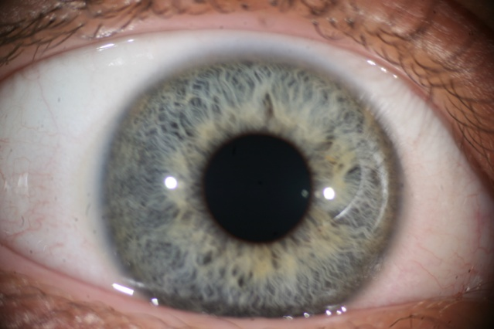  
   
A few months ago, North East Natural Health Centre presented to a local childcare center on the topic of allergies and anaphylaxis. The parents and care workers were present.  
   
What we noticed was that all of the children present had blue eyes, pale skin and either blonde or red hair! In iridology the blue eye type is an allergy type. These children are prone to allergies and inflammation of the skin and respiratory tract most commonly. These areas – the skin and respiratory tract are prone to being sensitive and dry. Green and brown eyed children can also be prone to allergies, but it tends to effect their digestive systems more so and they produce a lot more mucous.  
   
Babies and toddlers have higher reactions to allergies as their gut and immune system does not full develop until about 2 years of age. During this time, the little person’s body has been designed to be protected and nourished by breast milk.  
The breast milk provides all kinds of things like colostrum and bacteria and antigens that help develop a strong immune system and healthy gut lining.  
Some people are unable to breast feed for a whole range of reasons, and that is OK, but the following information still applies.  
   
An allergy is an abnormal response to a food protein that leads to a reaction on the skin, gut or respiratory system. Typical food allergens include eggs, cows milk, peanuts, wheat and soya.  
In a healthy body, with a healthy immune system, these proteins can be ingested without a reaction. The biggest contributing factors to a healthy body and immune system are: breastmilk until 12 months, a low allergy diet until 2 years of age, probiotics and a healthy diet.  
   
In children under the age of 2, after antibiotic use, gastro, infections or a long term poor diet, the cells and mucosal barrier on the linings of our skin, respiratory system and gut are damaged or underdeveloped and this allows for the allergenic proteins to leak through and the immune system over reacts.  
   
So, we need to not only identify the allergen, but also reseal the gut cells and protective mucosal barriers. This can be done by combing some natural medicines with a healthy diet.   
   
Given that childhood allergies such as eczema, gastric related food intolerance and asthma are on the rise, this kind of awareness is vital to create healthy children.  
   
Here are the 5 stages to allergy treatment from a naturopathic prospective  
   
1.     Identify the allergen – food allergy testing  
2.     Remove the allergen – find suitable healthy alternatives  
3.     Mop up the inflammation and control the symptoms – this can be with medicine or natural medicines  
4.     Repair the linings of effected area – gut, skin, respiratory tract (probiotics, herbs and nutrients can be effective here)  
5.     Improve the immune response: probiotics, herbs and nutrients + Drink plenty of water, eat adequate fiber, fruits and vegetables

**Articles and Information**

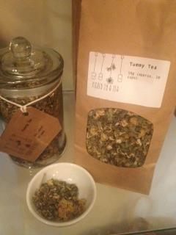**Tummy tea - "i ate too much at Christmas tea"**   
**Australian Supplied organic herbs:  Made by your local Naturopath.**   
  
Tummy tea is for anyone who suffers from bloating, indegestion, reflux, anxious tummies or that post Christmas -"i ate too much" kind of feeling. The combination of herbs are known as calminatives - so they relax the gut, reduce spasm and cramping. These herbs also balance acid build up in the stomach and soothe the stomach and bowel. Come in and sample our refreshing tummy tea - perfect to serve up after Christmas lunch.

**Tea of the Month Month**

**Product of the Month Month**

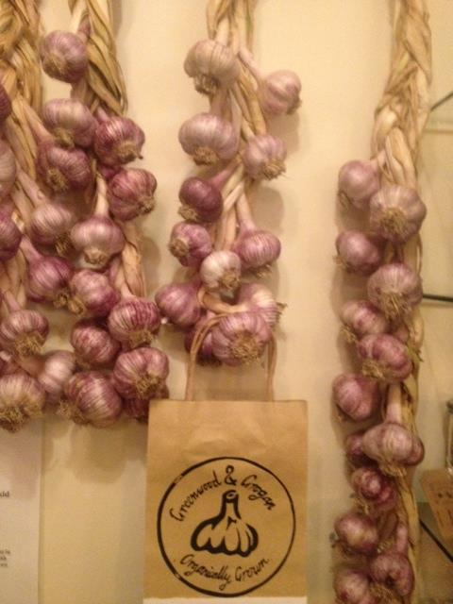 **G&G garlic**  
Stumped for a fresh way to get some of Mother Nature's finest antibacterial remedy?  
Pop into the clinic and pick up some G&G garlic.  
Not only does it fight the cold you have, your breath will ensure no-one will get close enough to infect you with another one.  
  
Now stocking Greenwood and Grogan Garlic. Organically grown and harvested locally in Allan's Flat. Garlic Plaits and single cloves available.

**Recipe of the Month Month**

**Ashtons birthday carrot cake - with a 5 star rating**  
 (thanks to Alli for sharing it with us)

* 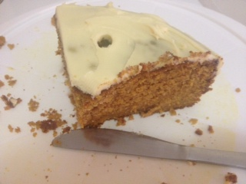2 cups (300g) self-raising flour
* 1 1/2 cups (225g) plain flour
* 1 tsp bicarbonate of soda
* 2 1/2 tsp ground cinnamon
* 2 1/2 tsp ground nutmeg
* 2 cups (440g) caster sugar
* 3 1/2 cups coarsely grated carrot
* 100g walnuts, roughly chopped
* 1 1/4 cups (310ml) vegetable oil
* 5 eggs, lightly beaten
* 300g sour cream
* 2 tsp vanilla extract

#### Cream cheese icing

* 500g cream cheese, softened
* 1 tsp vanilla extract
* 3 1/3 cups (500g) icing sugar

1. Preheat oven to 180°C. Grease and line a 25cm round cake pan with baking paper.
2. Step 2 - Sift flours, soda and spices into a large bowl. Add caster sugar, grated carrot and walnuts and stir to combine.
3. Step 3 - In a separate bowl, whisk oil, eggs, sour cream and vanilla until smooth.
4. Step 4 - Add to dry ingredients and stir until just combined. Pour into pan, smoothing top with a spatula. Bake in the oven for 2 hours or until a skewer inserted into the centre comes out clean. Stand for 20 minutes, then turn out onto a rack to cool.
5. Step 5 – For frosting, beat cream cheese using electric beaters until smooth. Add vanilla and beat well. Gradually add icing sugar, beating until smooth and creamy.
6. Step 6 – Split cooled cake into 2 layers. Spread bottom layer with half the frosting. Add top, then spread with remaining frosting.

**Kids Health Day  Month**

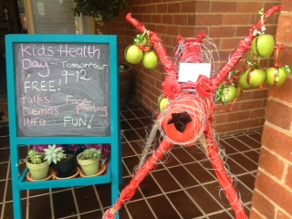**Kids health day**   
Our first Kids Health Day was lots of fun. Marcus and Marni (chiropractor and podiatrist) from Willoughby Chiropractic joined us for the day. We enjoyed meeting and talking to everyone who came along, with workshops and demonstrations for the parents, and of course the wonderful face-painting for the kids. We look forward to the next one later next year.

