Wet tongue? Hydrated?
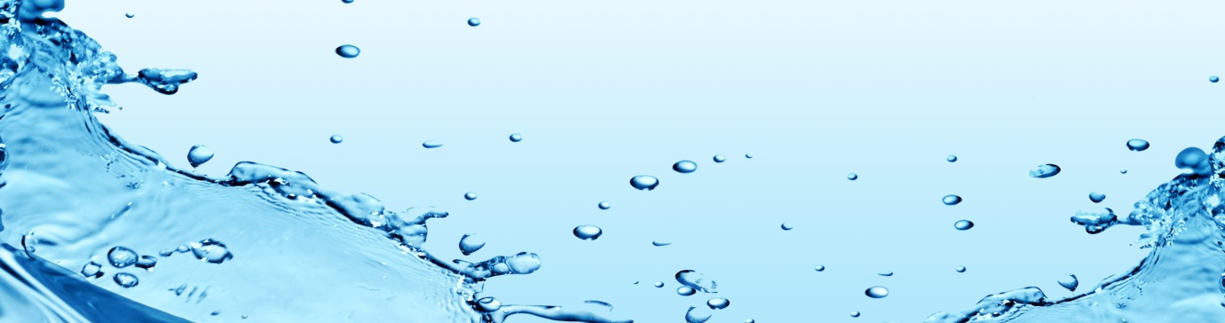

Drinking adequate water is the single most important change you could make towards better health?
How much is simple... Be sure there is a layer of water on your tongue at all times and that you pass clear light yellow wee.
Water composes 75% of your body & brain, 83% of your blood, 75% of your muscles and 22% of your joints.
Water was once the prescription for lowering cholesterol, weight loss, and appetite control, constipation, clearing brain fog, reducing muscle fatigue after and during sports, healthy glowing skin.... the list continues.
Here are the Naturopath’s top 5 water tips.
- Tap water is better than no water at all. If you are concerned, buy a filter.

- Drink 2 cups of warm water immediately on waking to rehydrate after sleep.

- Create a slow steady soaking rain of water through your body by drinking around one cup per hour, rather than a torrential downpour which you may wee out too quickly.

- Soft drink, cordial, coffee, milky drinks, alcohol all have calories and are classified as foods, not hydrating drinks.

- Pre prepared drink bottles keep you on track to drinking a certain amount each day if you need to start a good habit. Keep them in your view to remind yourself.

In short, think healthy foundations, think water. In fact you don’t need to think too much about it, you can just do it.. “near a sink, have a drink” is a good motto.
By Michelle Cose, Naturopath @ North East Natural Health Centre

