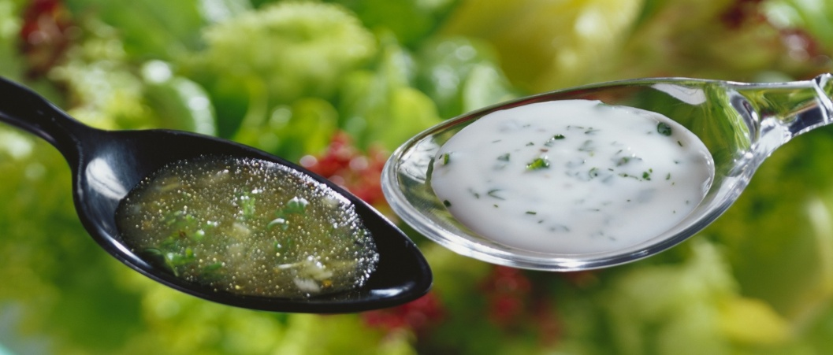
Medicinal Salad dressings

Salad dressings are also a great way to show off your home-grown produce. Add a few simple herbs like basil and parsley to a mixture of olive oil and lemon and you have the most simple and delicious dressing.
With ingredients such as vinegar, lemon and garlic featuring in these dressings, you instantly enhance the digestibility of raw vegetables and the rich meal to follow.

Salad dressing shopping list: If you regularly stock the cupboard with these dressing staples you will never have to buy a commercial salad dressing again!

- Lemons
- Oranges
- Tahini
- Olive oil
- Apple cider vinegar
- Fresh herbs (coriander, chilli, basil, parsley, mint, garlic, cumin)

Here are my top 5 favorite salad dressings that can also double as marinades and digestive medicines – how clever!

- Basic dressing: ¼ cup olive oil, ¼ cup of lemon juice, 1 handful of fresh herb such as basil or parsley – whisk together.
- French vinaigrette: ¼ cup olive oil, 2 tbsp organic apple cider vinegar, 1 tsp honey (optional), 1 clove garlic, 2 tbsp chopped mixed herbs. – whisk together.
- Creamy tahini dressing: 2 tbsp olive oil, 1 tbsp tahini, 3 tbsp apple cider vinegar, 1 tsp cumin. Whisk together, add ½ cup natural yoghurt if not dairy free.
- Orange sesame dressing: combine 3 tbsp olive oil, 1 tsp sesame oil, 2 tbsp orange juice, 1 tsp lemon juice, 1 tsp orange zest, 1 clove garlic crushed, 2 tsp Dijon mustard, 1 tbsp sesame seeds.
- Raw dressing: combine 1 cup lemon juice, 1 ½ cups olive oil, 2 tbsp grated ginger, 1/3 cup garlic crushed, 2 tsp sea salt.

Article by Naturopath Sophie Atkin @ North East Natural Health Centre

