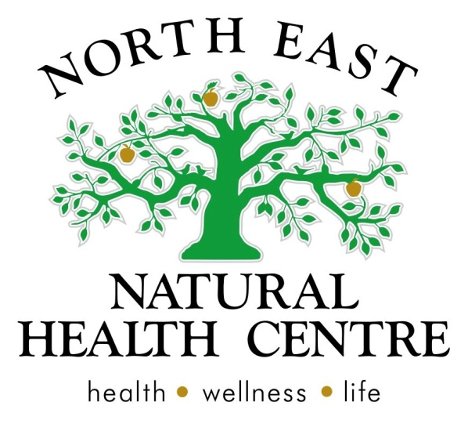

Clinic News
Have you been feeling 'buggy' with the change of season? Lack of hydration, changes in temperature (outdoors cold, indoors heating) can get your defenses down and make you more susceptible to infections at this time of year. We have noticed that many of our patients are presenting with their main health issue in combination with a cold/flu/respiratory infection at the moment.
Naturopathic treatments work amazingly for colds, flu's and other acute infections because our medicines support the body to recover quickly and more completely. We find that those using natural medicines and food as medicine to support their recovery do not have the lagging post viral coughs, runny noses and fatigue that can knock others around for weeks. So if you are feeling under the weather and just want a 'quick check up' ask our staff if a 'cold and flu test' would be beneficial for you.
After your appointment we can provide you with an absence from work 'sick' certificate.
**Available only for current clients, booking with our naturopath's. Longer consultations will be charged for if discussing more than one condition, or with a complicated history*
Mothers Day Specials
Create a healthy brunch for mum this mothers day with a combination of our delicious muesli and herbal teas. We recommend YOUR MUESLI (a new line of muesli created by a naturopath) and Lemon grass and ginger tea as the perfect combination for healthy mums, or try MOJO's museli for those who are gluten free.

Our specials for all of May include:
- PIA candles - 2 for $60
- Herbal Teas - 2 for $25
- Mojos museli - $ 22 (for a kilo)
- YOUR museli - $ 10 (Goji power) $20 (Incalicious)
- Chia seeds remain on special at $13.50

May has turned out to be both our welcome and goodbye month! We warmly welcome our talented kinesiologist Rosetta Holmes and sadly say goodbye to the lovely Alli from reception.
As it is mothers day this month, we thought we would take the liberty to spoil those great women in our lives and those who we meet everyday at the clinic. We have some great new specials, that would make delightful gifts for any healthy mum, and have titled this months issue the 'Women's Health' - read on for some health tips from our naturopath's and kinesiologist.
We hope you all had a Happy Easter everyone and wish all the special mums out there a very Happy Mothers Day!
Website launch
We are very excited to announce our new website! Our website is here to provide an additional service to our clients by way of healthy recipes, information and articles, contact details, services and very very soon an online shop! We encourage you to take a look and use these services to continue your health and wellbeing. Look us up at www.nenaturalhealthcentre.com/ home
Cold and flu tests and medical certificates
If you wish to use natural medicines to combat an acute infection (cold, flu, ear, nose throat, gastro infection) our cold and flu tests may benefit you. Cold and flu tests** are short consultations for 15 minutes so that you can get home and rest and allow your natural immunity to do it's job. You can always follow up with a complete naturopathic consultation later on, to ensure complete recovery and prevent reinfection.

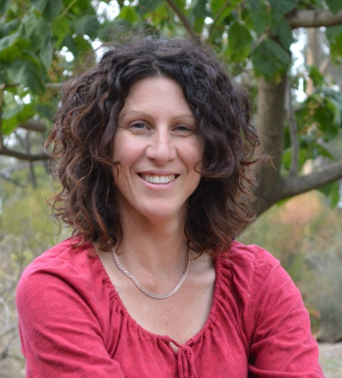
Welcome Rosetta
Rosetta has been with us for almost a month, working Tuesday and Thursday 9am - 3pm from our clinic.
If you would like to learn more about Rosetta and her kinesiology work, please contact reception, read her article below or visit her website: essentialdifference.com.au/

Farewell Alli
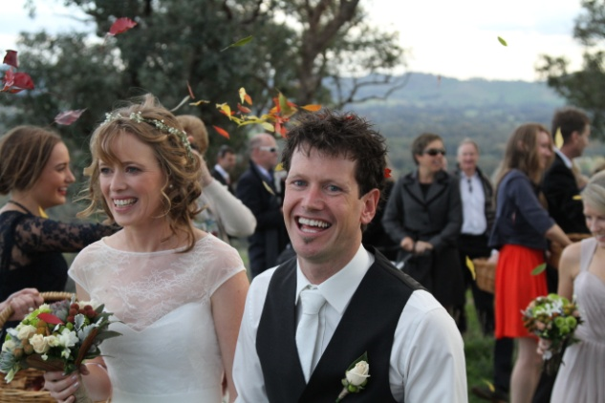
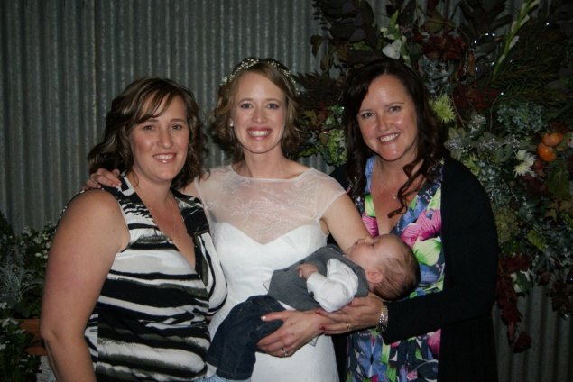
The lovely Alli has been our receptionist since October, and has now been offered full time employment elsewhere. So whilst we are sad to see her leave, we are excited to see where life will take her from here. Best of luck Alli - we will miss your smile and laughter.
As such North East Natural Health Centre is looking for a part time receptionist to cover 1 day a week, with flexibility for occasional availability.
Soph and Matt's Wedding!
Congratulations to Matt and Soph, who were married in the beautiful hills of Whorouly on April 26th.
We wish them all the health and happiness for the years ahead!

Articles and Information

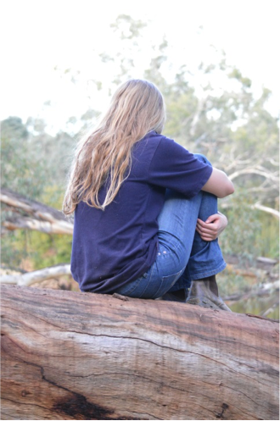
SUPER HUMAN - by Rosetta Holmes (Kinesiologist)
What do you believe?
Are you one of the many (like I was) who could do it all – without help? I remember feeling isolated and alone and it was all at my own doing! Yes you read it right – ‘at my own doing’. My stress levels increased so dramatically that I ‘shut off from the world’. Looking in through the eyes of my family I was “always angry or sad” and my children would say “mum, you never smile anymore”. Through personal development and Kinesiology I discovered I had a belief that “I was supposed to do it all”. That being a mum, wife and friend also included that ‘I’ was the one who offered the help, solved the problems, picked up the pieces and glued them back together again. Not to mention all the other jobs that being a mum and wife includes such as cook, taxi, maid, gardener, cleaner (you get the picture) while somehow still maintaining an intimate relationship with my husband! Wow - I was a Super Human!
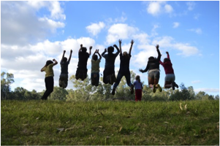
To function optimally I need all my cylinders running at their best and co-ordinating as a team. Now let’s face it, we don’t always run all cylinders in perfect harmony and that is okay! However, I realised this belief of mine, this system, was NOT serving me very well at all! I decided my choices, actions and behaviors had to change!
Confronting as it was, I began to explore what help looked like. I made a commitment to myself that when help was offered I would take a moment to honestly consider it rather than the all too familiar ‘no its okay – thanks anyway’, and then accept it gratefully. My world started to change………
In time I was able to ‘ask’ for help not just wait for it to be offered then get disappointed if no one could see that I needed help. Whether the answer was ‘yes’ or ‘no’ was irrelevant. You see, it has nothing to do with the answer or the courage to ask (even though it helps) rather the underlying belief that creates the result in the first place.
Beliefs are those internal rules that have been shaped by your environment at some stage and become so ingrained that it affects your everyday life. The funny thing is that this belief may have been relevant at some stage however if you find yourself feeling down, overwhelmed, sad, frustrated, alone, despondent, angry or upset as a result of the actions taken from that belief then it serves you in a negative way not a positive way. If you remain in that cycle physical signs and symptoms can soon follow….for example headaches, restlessness, impatience, outbursts of anger, crying without reason because the needs of the most important person are being ignored – yours! The most important member of your team is YOU!
So what comes first? Well, it would be difficult to change something if you’re not aware of it! So recognising that you feel like you do when a particular situation or conversation occurs is important. Generally that feeling is a ‘stress’ type feeling. If it happens over and over and over again becoming a ‘pattern’ and you don’t like the way it makes you feel or how you respond - you have a choice, either remain the way it is or change it. Even doing nothing is a choice. Changing behaviours and thought patterns that have existed for lengths of time, takes dedication and support to change. However I’d like to acknowledge again that the stress you and your body feel worsens over time and has the potential to turn into emotional and physical symptoms that become more noticeable and you may be faced with the need to take more significant action at a later stage.
Stress triggers the release of hormones and there are a variety of hormones that contribute to the way the body responds to stress. However the major ones are Adrenaline, Norepinephrine and Cortisol. These stress hormones make you feel awake, alert or ‘alive’. That’s because the body is in a fight or flight position. You may recognise that when you feel stressed your body responds with tight or tense muscles, your breathing becomes shallow and you feel your heart rate increase. You may also feel like there is a sense of urgency. This response is all well and good if you need to act to stay alive however I am seeing more and more clients in ‘adrenal overdrive’ due to the long term ‘stewing or procrastination’ process of issues/problems they face on a regular basis. As a result the body is continually releasing stress hormones that suppress areas of the body that are not required for a fight or flight response such as a suppressed immune system, digestion and libido.
Using Kinesiology techniques I am able to identify areas of stress in the body and work with you to regain balance and alignment which, in part, educates you to observe and understand your body’s responses and apply techniques when needed - all the while taking positive action towards a happy healthy you!
So ask yourself, “Is it repetitive?”
“Does it affect how you function?”
“Do you end up yelling, feeling frustrated, annoyed or angry?”
“Do you want it to change?”
If the answer to all these questions is ‘yes’ then you have probably come to this point many times before. My question to you is “how many times will it take before you do something about it?”
Recognition is difficult and making a change can be even harder however the results are liberating! This is where having the right support around you can make all the difference. So call and have a chat and let’s begin tailoring the support you need to achieve the change!
Please visit http://essentialdifference.com.au/ for more information about kinesiology and Rosetta Holmes, or call the clinic to book an appointment.

Product of the Month

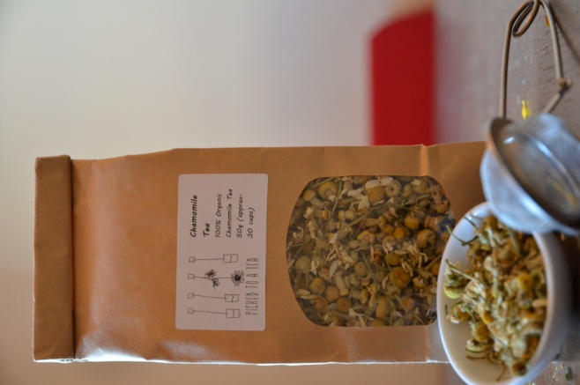
Chamomile tea
Chamomile is a safe and effective herbal tea, suitable for children over the age of 12 months. Chamomile has traditionally been used as a children's remedy for irritability, teething and sleep. Most children will enjoy the taste of freshly brewed chamomile flowers and as long as it is not too hot, often enjoy copying their mothers at 'cuppa time'. If your child is too young to drink tea but you think it would benefit them, breast feeding mothers can increase their intake and this will get through the breast milk and is a gentle medicine to calm your child's digestive and nervous system.

Recipe of the Month

Mothers Day Breakfast drink - works well with warm toasted muesli, croissants etc.
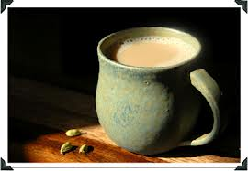
Cardamom tea - a twist to chia or coffee to warm our mums.
Makes 2 cups
6 green cardamom pods -lightly crushed
2 cups of milk
a little honey
cinnamon (optional).
Place cardamom in a saucepan and cover with milk. Gently and slowly bring to almost boiling. simmer for a few minutes and add a tsp of cinnamon and honey just before serving.

