Clinic News
Its time scarves, jumpers, bed socks and hot tea time of year. Getting into the swing of Winter can be a challenge for many of us. Sometimes it can seem like a battle of the mind and body. 'Stay in bed' our minds scream at us from under the doona, 'feed me more stodgy warm foods' cry our stomachs. As our minds and bodies try to adjust with less sunlight and the rhythm of hibernation mode, we can notice a drop in mood, energy and feel as though we are fighting a permanent cold or flu.
If this is you, jump under the doona with a bowl of steaming hot soup and read on for some inspirational winter energy foods and nurturing lifestyle tips. If these don't work you are welcome to come and see us for some more tailored advice and treatments.
WELLNESS TABLETS
For many years wellness tablets and kids syrup have been staples in many of your medicine cupboards each winter. As most of you already know we have been out of stock for some time and have just been notified that we will no longer be able to import wellness. The good news is that we have found a replacement that we are really happy with. ImuForce and de-Stuff for kids have been producing the same quality results in our clients and ourselves this winter, both as prevenetion and treatment for colds and respiratory infections. De- stuff for kids tastes very similar to wellness, so your kids wont even notice the difference. If you have run out of wellness and would like to try out our new range please do so. Otherwise speak to your practitioner for another suitable option.
SHARE TABLE - come in and swap some soup ingredients...or start a winter garden
Our Share Table is always a reflection of the season, providing the ingredients for seasonal recipes and remedies. Currently we have foods growing in the clinic garden that can be used to soothe sore throats, break up mucous, provide vitamin C and warm you up!
Come in and swap some 'soup' ingredients with us. We have kaffir lime leaves, dried bay leaves and chilies, garlic, pumpkins, cucumber, Californian poppy seeds and bean seeds.
USPA - Our day spa is open!
The full menu is available at:
www.nenaturalhealthcentre.com/uspa
USPA is Melbournes premier Day Spa and we are very happy to be offering these exquisite traditional, time honored treatments at NENHC. We have purpose built our day spa up stairs, as high as the tree- tops, for you to retreat to and enjoy the timeless experience that only a Day Spa can offer to restore your body, mind and soul. Treatment vouchers available with 30, 60, 90 minute options.
Winter breakfast idea
Start your day with this toasty warm breakfast. Simply cook up some porridge and top with Incalicious made by YOUR MUESLI. A delicious energy rich combo of quinoa, seeds and goji. YUM! Incalicious is available at the clinic in 1kg packages. We love it topped with stewed fruit as a healthy gluten free breakfast on cold days.
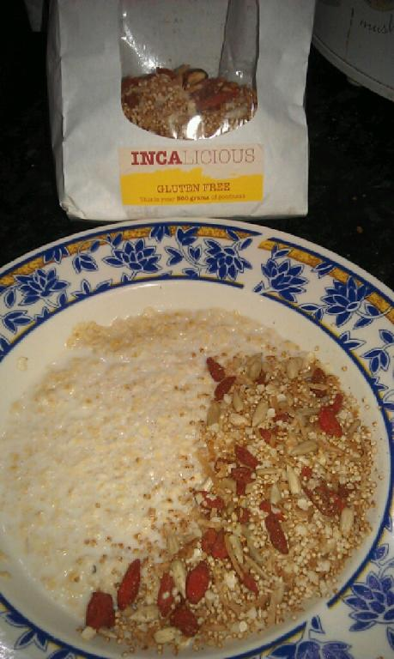

Winter Teas
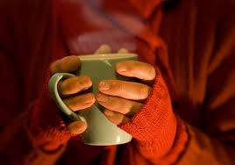
When you get a cold or infection the most important thing you can do is hydrate. This can be difficult in cold weather, so we recommend our patients drink warming herbal tea. YEP tea is a specific blend of yarrow, peppermint and elderflower to combat sore throats, mucous, and fevers. Come in and stock up your home dispensary! We also have a full range of herbal and fruit teas to keep your circulation warm and they taste delicious.
To keep you hydrated over winter we recommend:
YEP tea
Relax & Sleep Tea
Red Immune tea
Green tea and rose
Apple fruit teas
If you love our teas, bring back the jar for a refill at a discounted rate!

Articles and Information

Winter stagnation
Do you dread the winter months when you and your family easily succumb to coughs and colds, sneezing and sniffy noses, headaches, sore throats? Or are you someone who does not get 'sick' but notices a sluggish energy and mood and outlook? Or do you wish it were warm so your muscle aches and pains would settle and your appetite slow down?
The change in light and temperature effects all of us differently, but hibernation mode does make us more vulnerable to viruses and often contributes to feeling tired and emotional at this time of year, even without the headcold.
Instigators of a weakened immune system
A strong, healthy immune system is able to keep us well, even when those around us are coughing, sneezing and getting sick.
There are many factors that may contribute to the weakening of your immune system including stress, poor sleep, a lack of regular exercise, not enough rest and relaxation and making poor food choices.
Lifestyle factors to improve your mood and energy over winter
Sunshine breaks:
Make time for 20-30 minutes in direct sunlight daily over autumn to stimulate your immune system, warm your soul and put a peaceful smile on your dial. Our ability to absorb Vitamin D in winter is lower, so you need to make the most of your time in the crisp fresh air over the next few months of autumn.
If you work nine to five, walk or ride to work and eat lunch outside. Once it gets really cold, just go for a brisk walk around the block, after eating your lunch.
Warm drinks:
As the air cools down you will naturally feel less thirsty and perhaps less like drinking cold plain water. One of the main reasons we get more infections and allergies this time of year is that the dry cold winds and less time outdoors dry us out. This in turn makes it more difficult for our lymphatic system to clear out toxins and bugs. So keep topping up your water intake — drink it warm, hot, as herbal teas, with added cinnamon and honey, whatever it takes.
Vitamin C:
In autumn and winter, we naturally gravitate towards well-cooked stews, casseroles, soups and other warm cooked meals. This is important as these meals warm us up, but it also means that we eat less vitamin C. There are high amounts of vitamin C in most fruit and vegetables, however cold days mean we crave less fresh fruit and cooking our vegetables destroys the vitamin C content. Boost vitamin C with a glass of fresh OJ, lemon water and garnish meals with fresh parsley and coriander. Leave the pith on citrus fruit to increase vitamin C and talk to your health professional about a supplement if you are still struggling with pre-winter colds and infections.
Your body also uses large amounts of vitamin C during if you do catch a cold or infection. At times like these eating vitamin C rich foods is important, but it is difficult to reach therapeutic dose unless you have a lot of fresh produce. Speak to your naturopath about dosage ranges that will work for you.
Walking: A daily walk or more intense exercise if you’re up for it will keep your immune system bouncing and mood sunny. Walking clears the mind, boosts your energy levels and filters toxins and bugs through your lungs.

Recipe of the Month

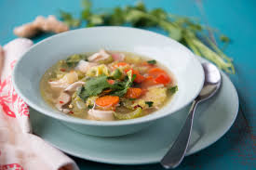
IMMUNE SOUP
This soup will warm your cockles and your toes and can even be used a food style painkiller - nurofen soup anyone? ... it tastes much better!
- 1 tablespoon (15 ml) olive oil
- 1 onion, diced
- 3 spring onions
- 1 bulb of garlic - minced
- 1 thumb sized piece of fresh ginger root grated
- 1 1⁄2 cups salted vegetable soup stock (made from herbamare salt)
- 2 cups fresh, sliced shiitake mushrooms and oyster mushrooms
- cayenne powder, if desired or 1 fresh chilli
- 1 tsp of tumeric powder
- 1 tsp of palm sugar
- 2 Chicken breasts (cook first and finely cube).
- Asian Green vegetables.
- Coriander (to serve)
- Lemon (to serve)
Heat the oil in the soup pot. Add the onion until brown. Then add the garlic, ginger, tumeric and stir until fragrant (don’t burn). Add the water and the stock. Then add the chicken and the palm sugar and stir. Cover with more water. Add the chilli. Bring to the boil and then reduce to simmer. Add you vegetables until just cooked. **if you are sick with a cold save half the garlic and stir it in just before serving.
Serve with a squeeze of lemon or lime juice and some fresh coriander on top to mix through.
** Options** For extra greens stir fresh coriander, celery leaves or parsley through soup when serving.

