Healthier Old Age
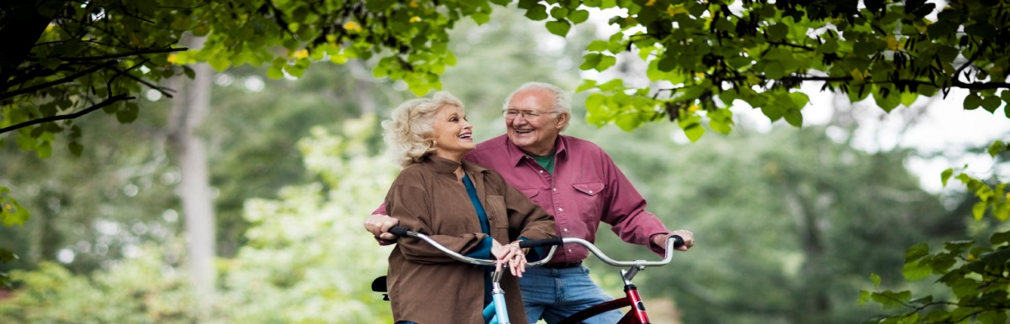
Age is not just defined by the number of years a person has lived. It is also determined by a person’s biological health – how resilient the body cells are holding up.
Creating health is like a bank account – you are given different ‘opening balances’ depending on your genetics and you are either ‘depositing’ or ‘withdrawing’ on this account depending on whether you are looking after your health of neglecting it… this account will eventually run out, but how slow or fast it occurs depends on your choices.
People age at different speeds. We all know people who are in their later years who live with few limitations, are active, mentally alert and passionate like a much younger person. I have asked many of these people how they have lived and the answer is often the same.. ‘simple, unprocessed fresh foods, positive mental attitude and outside interests that keep them active.” Some have had health problems that have been the turning point to their change for a healthier lifestyle.
The foundations of health are quite simple.
- Nature has intended us to eat food from the gardens (not from packets) with fresh meat, eggs, legumes, nuts and seeds. This means at the supermarket you need to keep to the outside aisles predominantly.. Vegetables, refrigerated goods, meats. Packaged food that does not spoilt is unnatural to our body.
- Our digestion is strong at breakfast & lunch and weak in the evening so eat a lighter tea meal. Make two thirds of every plate of food vegetables and salad. Fruit is excellent when in season and fresh. Look for local produce for the freshest choices. 1-2 pieces per day is enough unless you have a very high level of physical activity otherwise you may gain weight.
- Drink plain water – enough to keep a layer of water on your tongue at all times and your wee clear. These are the signs of good hydration. Nothing substitutes for water. Nearly all coloured drinks are counted as food as they contain calorific energy and will add to your calorie intake.
- Reduce you meat intake to 10-15% of your diet maximum. Don’t let meat exceed the size of the palm of your hand at any one meal. Have one day per week meat free to rest your digestive system. Use plant proteins such as legumes, nuts and seeds.
We have great opportunities for strong social networks in North East Victoria and great weather for getting into the garden, walks, cycling, swimming etc.
Is it time you revisited your greatest asset –‘Your good health’ and took another look at ways to improve your pathways to a Healthy Older Age?
Article by Naturopath Michelle Cose @ North East Natural Health Centre

