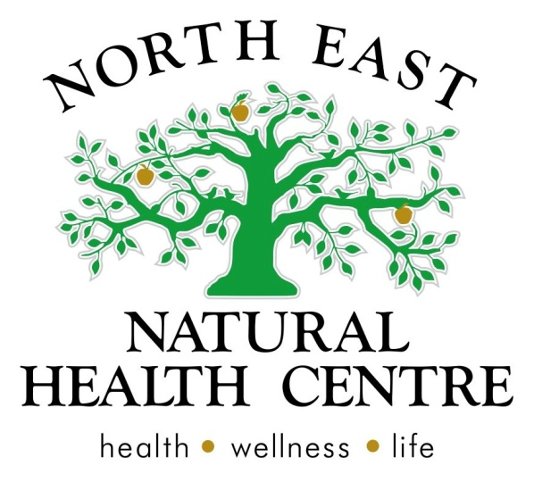

Clinic News
Share table is back
Thanks to the rain and cooler weather, our clinic garden is starting to grow and we have more produce available to share. Come into the clinic and swap some produce and take a look at our new share table.
Specials
This month we are offering all clients (return and new) a $10 discount on all Naturopathic appointments. This special is available until the end of April (April 30th). This is a good opportunity to have a check up before winter hits, so you can prepare your winter mood and work on your immunity. Please call reception to book your appointment 03 57215886.
Vital greens and vital greens for kids is still on special this month. Vital greens is a combination of vitamins and minerals for everyday wellbeing. Vital greens will remain at $54.80, so now is a great time to top up your supplies before the winter flu season begins. We also have a kids version for optimal nutrition in fussy eaters on sale at $48 this month.
Welcome Rosetta
Rosetta Holmes is a Kinesiologist who will be starting with us on Tuesday April 1st. Rosetta will be available on Tuesdays and Thursdays.
Kinesiology is a holistic health approach that addresses performance and function of the human body. Also addressing both the physical and emotional effects of day to day living and aims to restore and realign the body to its natural order.
Rosetta has a special interest in Children's health and says 'children often have difficulty expressing ‘what they mean’ or ‘how they feel’ for a variety of reasons. As a result children often go un-noticed and struggle to apply effective strategies during their childhood and by default these patterns follow them into adolescence and adulthood'.
Rosetta through her work is seeing more and more children, struggle with the increasing stressful environments of school and social interaction directing her focus on Child Development, in particular to improve co-ordination, positive behaviour, learning ability and outcomes, resilience, strategies and comprehension.
Coming soon
Over the next month we will be working hard to finalise and launch our new website, which is packed full of information, recipes and inspiration to keep you healthy and well. We will have HICAPS service available very soon to help with processing your private health rebates and look forward to introducing our new team of practitioners to you very soon.
Since Eli's birth (Belinda's baby), we have been focusing in on the little people in our lives and thought it was a great time to talk to you about children and natural therapies. Children respond so well to natural medicines and nutrition, so this months newsletter is on everything kids!
Read on for some great tasting children's recipes and some articles on how to improve your child's immune system for the coming cold snap.
When we think of childrens health we can forget the person who is most important in the childs life... Mum. Drop into our pantry area to explore some healthy and luxurious gifts for mothers day. Come and see our wonderful range of PIA candles, herbal teas, rustic hyde and other lovely gifts for healthy mums.
We will also share with you some herbal teas that children love and our specials this month that includes vital greens for kids, chia seeds (chia pudding is a great recipes for weening children) as well as a special for all consultations (new and return) until the end of April.
Advanced Learning - seminars our practitioners have attended.
Pregnancy: After attending a 4 day intensive on pregnancy in Melbourne and various workshops in children's health last month, our naturopath's are now up to date with the latest research and information on applying natural medicines for fertility, pregnancy and children's health. We have programs available to optimise your health and wellness and prevent uncomfortable symptoms with natural medicines during these key times.
Addictions: Our naturopath's have also attended a seminar on addictions and are using this latest information to support patients with natural medicines during times of anxiety, depression or when experiencing addictive behaviors (smoking, food cravings etc).

Rosetta has experienced positive outcomes with children who have social, emotional and learning difficulties. Individual consultations provide a ‘safe space’ for child and parent to work with Rosetta on areas of concern. Children are quick learners and with a nurturing and supportive, trustworthy environment Rosetta teaches strategies and empowers children to be their best. A happy, grounded and confident child will be engaged in their learning and their outcomes.
Rosetta is a member of the Australian Traditional Medicine Society and as such is covered by a variety of Health Providers.
Facebook: https://www.facebook.com/EssentialDifference
Web: http://essentialdifference.com.au/
Email: essentialdifference@gmail.com
To enquire about an appointment please contact us on 03 57215886.
Coming soon
Over the next month we will be working hard to finalise and launch our new website, which is packed full of information, recipes and inspiration to keep you healthy and well. We will have HICAPS service available very soon to help with processing your private health rebates and look forward to introducing our new team of practitioners to you very soon.

Articles and Information

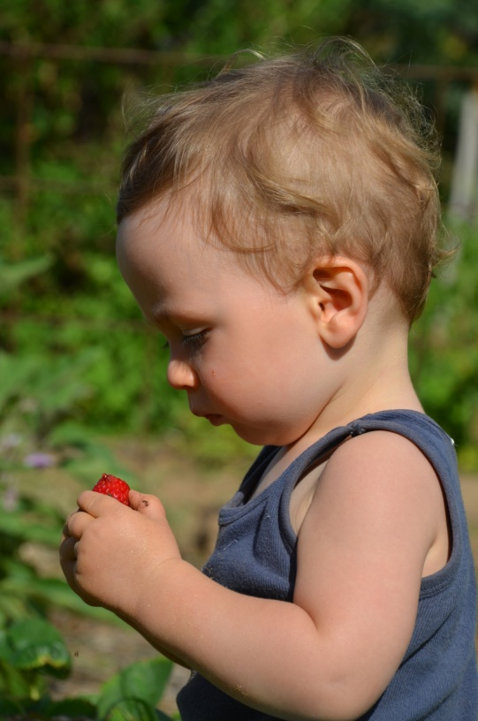
Naturopathic approach to children's health
#children's health: #tummy troubles #anxiety and stress in children #colds and flues #fussy eaters #behaviour and mood problems #allergies #skin reactions and excema #asthma and respiratory issues # glandular fever recovery
Children respond well to natural medicines and we love seeing them recover quickly. At NENHC we see children of all ages, from new born babies through to teens. For the most part we work with them and their parents to achieve more positive health. Our approach is to alleviate symptoms and then help them regain vitality so that further infection or ill health can be managed more effectively in the future. It is common for children to get sick and at times get tired and feel anxious, and so long as it passes quickly, is a sign of an over all healthy child. if symptoms of cough or infection linger, or they are unable to sleep for many nights due to stress, or if the tiredness continues for days, then your child may benefit from natural medicines. When your child is unwell, we can use gentle natural medicines to help reduce pain, and discomfort and then look at their diet and nutrition to improve their overall health. We have strong relationships with many other health practitioners in town and can arrange referrals to chiropractors, physiotherapist and other body work therapist if required.
Allergy's and children
A food intolerance is an abnormal response to a food protein that leads to a reaction on the skin, gut or respiratory system. Typical food allergens include eggs, cows milk, peanuts, wheat and soya.
In a healthy body, with a healthy immune system, these proteins can be ingested without a reaction.
Common signs of allergies in children include: dark bags under the eyes, pale skin, white spots on the nails, ongoing snuffly nose, constant mucous (cough, runny nose, sneezing) and poor appetite or nausea.
Babies and toddlers are prone to these allergies as their gut and immune system does not fully develop until about 2 years of age. During this time, the child’s body has been designed to be protected and nourished by breast milk. Breast milk provides all kinds of things (colostrum, bacteria and antigens) that help develop a strong immune system and healthy gut lining.
Some people are unable to breastfeed and that is OK, but the following information still applies.
After antibiotic use, gastro, infections or a long term poor diet damage the cells and mucosal barrier on the linings of our skin, respiratory system and gut are damaged and this allows for the allergenic proteins to leak through and the immune system over reacts. This reaction is worse in little children.
To fix the allergy reaction, we need not only to identify the allergen, but reseal the gut and improve the immune system reaction.
Given that childhood allergies such as eczema, gastric related food intolerance and asthma are on the rise, this kind of awareness is vital to create healthy children.
Here are the 5 stages to allergy treatment from a naturopathic prospective
Identify the allergen – food allergy testing
Remove the allergen – find suitable healthy alternatives
Mop up the inflammation and control the symptoms – this can be with medicine or natural medicines
Repair the linings of effected area – gut, skin, respiratory tract (herbs and nutrients can be effective here)
Improve the immune response: herbs and nutrients + Drink plenty of water, eat adequate fibre, fruits and vegetables
Pregnancy and natural medicines:
Naturopathic pregnancy care is about wellness. Our aim is to help you feel safe, informed, relaxed and supported through your pregnancy journey. Our role is to keep you as comfortable as possible and monitor you for optimal nutritional wellbeing. As a naturopath we are mostly interested in your physical and mental wellbeing and optimal nutrient requirements. Pregnancy should be a time that women enjoy. However due to increased nutritional demands required for growing a baby and placenta the following symptoms can be common. All these listed can be treated or managed well with naturopathy. We are well educated on safety of natural medicines during pregnancy and interactions with other medications.
- Stress management
- Nausea and vomiting
- Elevated glucose levels
- Food cravings
- Increased weight gain (more than is required for a healthy pregnancy)
- Sluggish bowels
- Stretch marks
- Tiredness
- Lack of sleep
- Mood drops/ worried about Post natal depression
- Baby brain
- Short of breath
- Colds and flus
- Asthma flare up
- Leg cramps
- Swelling and fluid retention
- Low energy
- iron deficiency

Prevention or management of (in conjunction with medical treatments):
- Gestational diabetes
- Autoimmune flare ups
- Pre-eclampsia history
- Post natal depression
- Miscarriage prevention
- iron deficiency
- post birth recovery and convalescence

Product of the Month

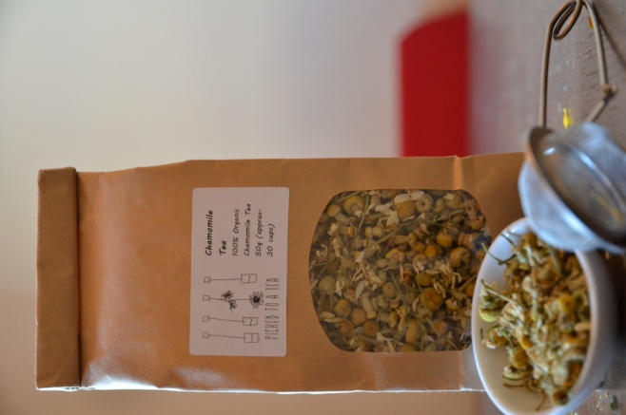
Chamomile tea
Chamomile is a safe and effective herbal tea, suitable for children over the age of 12 months. Chamomile has traditionally been used as a children's remedy for irritability, teething and sleep. Most children will enjoy the taste of freshly brewed chamomile flowers and as long as it is not too hot, often enjoy copying their mothers at 'cuppa time'. If your child is too young to drink tea but you think it would benefit them, breast feeding mothers can increase their intake and this will get through the breast milk and is a gentle medicine to calm your child's digestive and nervous system.

Recipe of the Month

Weening babies
Here is a recipe for the really little ones, but you can easily adapt it and make it for older children too.
Often we think of giving children plain foods, but breast milk actually is full of flavors, and it changes daily, depending on what you have eaten yourself. One way to reduce the chance of children becoming fussy eaters, is to give them full exposure to many flavors at a young age. Children all over the world start on mild spices from their first meal. Here are a couple of ideas for adding 'spices and herbs' to your little ones diet. All these spices enhance digestion, boost immunity and help increase appetite.
Add:
Cinnamon to rice cereal
Tumeric to mashed potato
Fresh basil to mashed Avocado
Here is an idea that would work well for any children of weening age
Chia pudding:
Use this instead of rice cereal for a nutritionally superior breakfast.
Great for gluten free and nut free families or any-one in between.
* Tip: takeaway option: make up a batch and pop into individual containers - ready to go.
1 tablespoon of chia seed to 1 cup of liquid (use some breast milk, water or milk of choice). soak chia in liquid overnight so that they soak up the liquid and become like a pudding.
When ready to serve, spoon a portion into a small bowl and mix in a 1/2 tsp of cinnamon and some apple berries or banana.
Enjoy :)

