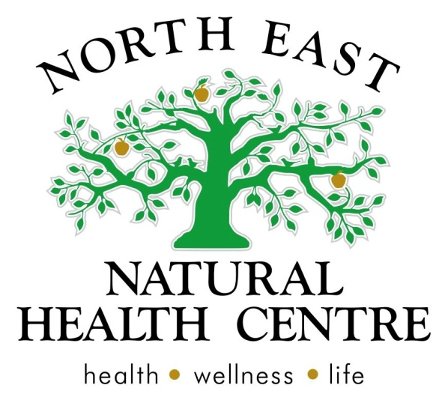

Clinic News
We hope you are enjoying a healthy start to 2015!
February is the month to get into health and wellbeing and with campainges like Feb Fast happening across the country, everyone has the chance to detox from alcohol and donate to a good cause. We like to take it a step further and use Feb to kick start your health, with a naturopathic detailed detox program.
Stay cool and for all those children heading back to school this week, we wish you the best start to the new year!
Low energy: so refresh & detox
- Feeling sluggish
- Tired
- Head fog and poor memory
- Bloating and constipation
- Dull skin
- Flat mood
- Constantly unwell
- Dark circles under the eyes.
Naturopath's Sophie, Belinda and Michelle will help you to:
- Create an individualized action plan using natural medicines to filter and clean your liver, kidneys, digestion and skin.
- Refresh your food choices to maximize your energy and wellbeing.
How can detox create better energy?
If you can picture the fuel filter in your car – if you don’t look after it, the filter partially clogs up and the motor becomes sluggish.
Your body has four main filters that work to keep you well. Clean filters regularly for better health through our detox program.
Call reception to book in.
Share table thank you
Thank you to Karen for the vegies on our share table this month and also to Killawarra Garlic for your delicious cloves.
We are extending our services to you!
We have professional rooms available in our award winning multi-modality clinic. If you would like to be a part of our team, please contact reception to book a time to speak with our managers. Rooms will best suit a health consultant, massage therapist or other natural health practitioner.

Articles and Information

Detox - is it for you?
By naturopath Belinda McPherson
Do you get your filters changed in your air conditioning unit prior to summer? Do you change the oil and filter in your car? You do this to ensure your unit or car is running smoothly and won’t break down throughout the year.
So why don’t we do a regular clean of our filters or cleaning system?
A regular detox of the four primary filters of the body (liver, kidney, bowel, skin) ensures that our body runs smoothly.
People who have the following can benefit from detoxification?
Digestive issues-bloating, burping, constipation, stomach pains
Food allergies or intolerances
Chemical sensitivities
Skin conditions- psoriasis, acne, rashes
Difficulty sleeping, fatigue, brain fag
Mood disturbances, irritability, anger, fear
Muscle/joint aches and pains
Recurrent infections-thrush, colds and flus, hay fever, sinusiti9s
Fertility and preconception
Menstrual issues, PMS, pain, hormonal issues
Headaches
A detox that promotes healthy cleaning of ALL our filtering systems gives our body the best chance to reverse disease processes, change our health and promote long term wellness.
When all organs and systems of our body are clean and working at their optimum you may experience, more energy, better sleep, clearer thinking, weight loss, better immune system, great digestive system,
The five basic components of any detoxification program should include:
- Exercise: every day such as yoga and walking (especially in nature)
- Regular sweating: a sauna, steam room, exercise or yoga class
- Healthy nutrition: rich in organic fruits and vegetables and filtered water/herbal decaffeinated tea
- Support to all organs or channels of elimination.
- Self-reflection: such as meditation and breathing-focused relaxation
Make sure you read the following weeks articles to find out more about the benefits of detoxification.
Preconception, pregnancy and detoxification
By Naturopath Belinda McPherson
So that time in your life has come….you can hear the little ticking of your biological clock…. Tick, tick, tick…. It’s time to change your life for EVER and bring a human being into the world. Or maybe you have been trying for a while and it just “isn’t working.”
There is no one reason why conception doesn’t come easy to some. However the majority of our clients who are having difficulty conceiving or are planning to conceive benefit from a preconception programme that includes detoxification.
An ideal preconception/detoxification programme should be completed 3-4 months prior to conception for optimal safety. This allows the cells, organs and body to eliminate toxins, clear out the system and allow everything to work at its best.
How does detoxification benefit conception?
There are many reasons, from healthy, balanced hormones, to optimal absorption of nutrients to help baby grow. With detox, less fat soluble toxins will be transported in your breast milk and across the placenta. Pre-conceptive detoxification provides a healthy environment with beneficial bacteria that reduce the likelihood of skin and food allergies/ intolerance, supports the babies developing immune system and digestive tract. When you do a pre-conceptive detox program at our clinic, we also ensure you have optimal levels of nutrients to meet the growing demands of the fetus and placenta.
Proprioceptive detox for men?
Preconception care is not only for woman… sorry guys its not all just about fun! Your DNA makes up 50% of your babies DNA and your health is an integral part of the conception process.
So you want to get started on your health prior to seeking support from a health care practitioner?
Start by increasing your hydration (water, and decaffeinated herbal tea), eliminate alcohol, stop the chemical invasion- smoking, junk food, processed food, chemical laden cosmetics, increase leafy greens and lean proteins. And finally seek help before trying to conceive is consuming your life and taking all enjoyment out of your life.

Product of the Month

Chia Seeds
Occasionally a product comes on the market which deserves praise for incredible health benefits - Chia seeds are a great detox food, especially if your bowels are sluggish or your skin is dry.
Two tablespoons every day has the following benefits:
- Constipation - swells in water and makes bowel motions super easy to pass and bulks up the stool for healthy bowel muscle strength.
- Provides over 5000mg of omega 3 oil. Our counselor Eva noted medical studies that suggest this level is mandatory for depression, anxiety and mood disorders. Omega 3 is also recommended as brain protection for dementia.
- The omega 3 is sustainable and easily grown unlike fish oil which takes a heavy toll on the environment with many cheap low quality retail fish oil supplements having high heavy metal levels.
- Contains 150mg of calcium as a substantial contributor to your daily need for bones, teeth and nerves.
- High protein and low carb - great for "paleo", health and weight conscious eaters.

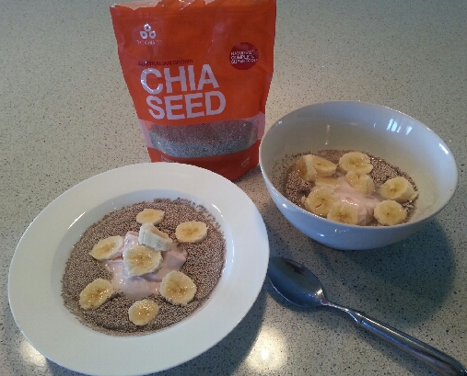
Here is Michelle's daily breakfast:
2 tablespoons of chia seeds, Half a cup of cool water, 2 tablespoons of yogurt and half a banana. Let sit for 3 minutes and enjoy.

Recipe of the Month
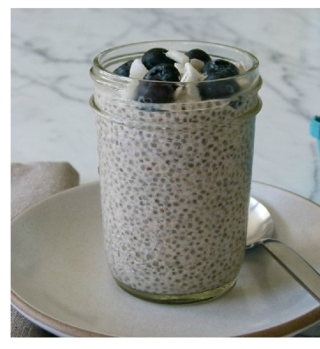
Chia Pudding
This pudding is so delicious it can be enjoyed as desert, yet so healthy you can eat it for breakfast. Its an adaption of Thai sticky mango rice - Perfect for summer!
3 tablespoons Chia seeds
1 cup of coconut milk
Berries or mango
Combine coconut milk and chia and whisk well. Let sit for 5 mins then re stir. Place in fridge overnight and enjoy the next morning with stewed fruit, berries or sliced fresh mango.

